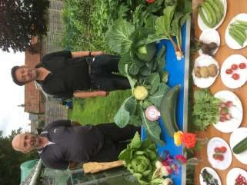

The Newsletter for Middleton on the Wolds

Issue No 19

September 2020

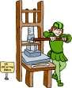
NEXT COPY DATE
14th September

Please send in your contributions to middletonflyer@yahoo.com by the end of the copy day. If I don’t acknowledge them please get in touch to make sure they have arrived.
There is a change to the Quiz Page for this month. I
belong to a wine tasting group and a friend of mine compiled a word search with 15 grape varieties and a hidden message. He has given me permission to share it with you; I hope you enjoy it.
In past issues we have published obituaries given to us by villagers. We will publish any given to us by a relative of the person who has died or by a friend but please check with the closest relative that they are happy for it to be published in The Messenger before sending it in.
The daffodil poem on page 4 was sent to me by email, obviously doing the rounds. I hope you find it amusing.

Lyn
4 The Paddocks 219500
Front Page Picture:

Two Middleton Gardeners Cousins, David Newlove and John Smith
As this year's produce show in July was cancelled John who won the vegetable cup in 2019 decided to put on his own show for David and Louise. Looks like a good one and maybe he would have won the cup again. Hopefully July 2021!!
If you have any ideas, comments or complaints (especially complaints) you want to share then send an email to middletonflyer@yahoo.com.
Remember, we can’t respond unless we receive your message.

editorial
So, that was the Summer that was. But what was it? By the end of June we were all pretty much used to the notion that life in the immediate future was not going to be as we knew it and when the schools did finally close for the holidays we were all aware of social distancing and the like. But where could you go for summer? What could you do?
Resorts and hotels were open – then they weren’t. You
could fly to Spain – then you couldn’t. You were told you should start going out – and then that you shouldn’t take unnecessary risks.
Anyway, I hope you managed to clear enough of the minefield to enjoy at least some of the glorious weather we’ve had and, if you did manage to get overseas, that you weren’t too inconvenienced by going into quarantine.
Now the schools are reopening distancing and isolation will be a little more difficult so we should remember to keep taking the usual precautions, especially washing your hands regularly. And don’t forget your daily exercise – it’s not just for COVID; it’s for life!
Elsewhere in this edition there is a very clear article about that perennial problem of owners not cleaning up after their dogs. I hate to bring this up again, but I hate even more that I have to. Guys, there is no such thing as the dog poo fairy. Sort yourselves out.
Otherwise, Stay safe.
Cheers, Mike
ADVERTISING COSTS for the Messenger
Rates Month Year

Whole Page £25 £150

1/2 Page £15 £100

1/3 Page £10 £60
Full colour - Print run 500 copies
Contact: Tina 01377 217242, middletonflyer@yahoo.com
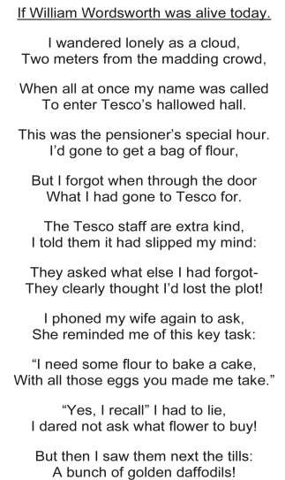
Middleton has for a number of years been proud to be a part of the World’s Biggest Coffee Morning, fundraising for Macmillan Cancer Support. Margaret Eastwood organised the early coffee mornings, followed by Hazel Kazer and recently Emma at Wolds Waves.

They did a wonderful job with raffles, bring and buy, not to mention the coffee and cake. Of course things are different this year and the large-scale coffee mornings can’t take place due to the COVID-19 pandemic.

However, let’s try to do our bit in a small way – in fact in lots of small ways!
As we have come out of lockdown but are still being very careful, many people are entertaining a handful of friends in their gardens for coffee and biscuits, tea and cake or even wine and nibbles – all at a safe social distance. This would be an ideal opportunity to ask your friends for a donation towards Macmillan Cancer Support.

A donation of £120 has already started the collection. If we try to hold extra little garden parties during September we would be able to send a substantial amount towards the charity. The donations collected could be left at the Post Office or given to Hazel Kazer.

Please keep the number small along with the government guidelines and set the chairs at the required social distance

There will be a collection box in the Post Office for donations from anyone who would like to support this amazing and very necessary charity

Local Birds & wildlife
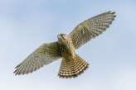
What’s that noise? Is it a blackbird on steroids with a loudhailer? No, it was actually three young kestrels who had obviously just fledged and were finding the trees on the embankment a rather overstimulating environment. They were taking short over-flappy flights from branch to branch, with their wings and tails catching slightly in the twigs and leaves, and calling to each other (or quite
possibly shouting to their parents for food). It was lovely to see and brought some excitement to the garden, which has been a bit quiet of late. Another cheering sight for me was a leveret (young hare, but I bet you knew that) sitting peacefully at the side of Warter Road. It was very skinny, with unfeasibly large ears, and watched me for a bit before lolloping away into the undergrowth.
It has been great this year hearing so many swifts screaming over the village.
There have been quite a lot of house martins as well – whilst standing chatting (in a socially distanced way) outside the Village Hall the other day a family of them was leaving the nest next door and swooping over our heads, practically putting new partings in our hair. What have really been missing this year though are swallows, until one weekend in early August, when suddenly there was a big cloud of them swirling around and calling. It was the first time this year that I had heard their joyful warbling chattering song, and sadly I haven’t heard any since, so they must have just been passing through. I looked back at what I had put in the previous Messengers: September 2018 I wrote “…more swifts screaming round the Village, but fewer house martins and hardly any swallows” and in July 2019 “Seen fewer than 10 swallows flying around Middleton”.
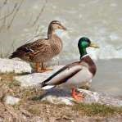
Let’s finish on a happier note. I have an enormous book “Birds Britannica” by Mark Cocker and Richard Mabey, which is a rich source of anecdotes, stories and facts, and I was interested to find Mrs. Beeton’s take on the mallard: “It is to be regretted that domestication has seriously deteriorated the moral character of the duck. In a wild state he is a faithful husband, desiring but one wife and devoting himself to her; but no sooner is he domesticated than he becomes polygamous, and makes nothing of owning ten or a dozen wives at a time.” I’m sure many of us have
found ourselves hurrying small children past the village green in early spring to avoid scenes of violence and debauchery, so she might have a point!
Let me know anything interesting turning up/happening in your garden, or round the village; contact me on lavenderbarbara97@gmail.com or 0777 192 7868.
Barbara

QUIZ PAGE
- What is the state capital of California?
- Which actor has played Ken Barlow on Coronation Street for over 40 years?
- Name Nottingham's River?
- Who was the first monarch to be addressed as Your Majesty?
- What is the UK's best selling chocolate bar?
- Which football team is known as 'Minstermen'?
- Who wrote the classic novel Les Miserables?
- What is the capital of Poland?
- Who originated the saying 'Am I Bovered'?
- In the 1900's the first Highway Code issued but in which decade?
Quiz set by Rowland Wooldridge All answers on page 14
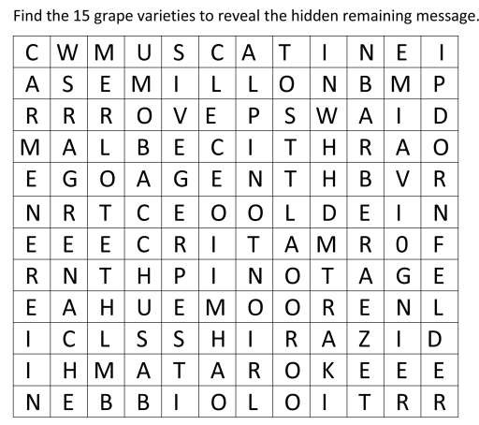

LOCAL HISTORY
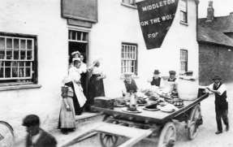
CAKES AND ALE

“The number of public-houses, which present themselves in almost every village, are allurements to deviate from sobriety, economy and domestic comfort which few of the lower ranks can resist, and it is scarcely possible to point out such simple and expeditious means of reforming their
characters, and improving their conditions as that of considerable reducing the number of these nuisances, leaving only what would be requisite for the accommodation of travellers, in convenient situations and at regular distances, and gradually suppressing all others not so circumstanced as perniciously superfluous.”
This high-minded broadside against the meagre pleasures of the working man when hard labour and insecurity were the norm was delivered in a report to the Board of Agriculture in 1812 by Henry Strickland son of Sir George Strickland of Boynton. But to return to reality, Baines’ 1822 directory lists two such “nuisances” in Middleton the “Robin Hood” with landlord John Petch and “The Board” with Matthew Kirby” which could have been the former coaching house in South Street parts of which are said to date from the 18th century.
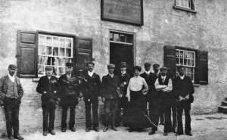
The “Robin Hood”, attractively situated next to the church, boasts a mounting block and the pub’s nearness to the place of worship raises the question of whether there was in centuries past an earlier building on the site used for the sale of home brewed“Church Ales” a practice in pre-
reformation and less censorious times used to raise money for church maintenance and poor
relief once described as “A crude precursor of today’s parish fete.” Over the years the pub was associated with the annual feast of the Middleton Branch of the Ancient Order of Foresters which had been founded on the premises by William Moate in 1839. Other licensees over the years have included Thomas and Elizabeth Petch, John Outhret, Thomas Appleton, Mr Blanchard, John Postill, Frederick Dent, George Watson, Samuel Beal, Mrs Hotham ( noted for her skill in smoking a cigarette to the very end without spilling the ash),
George Bennett and Nan, Clive and Jill Fletcher and at present Mike and Lyn
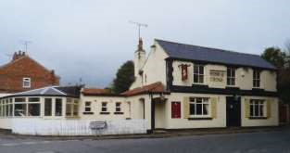
The 1841 census lists Christopher Witty as a brewer in South Street and in 1867 the “Rose and Crown” with its garden, stabling and granaries etc. was advertised for letting and extensive business had been done at the brewery for many years. In later times the pub became particularly popular with
Hartley ever resourceful in trying times.

young people and during the last war it was the unofficial and clandestine rendezvous for members of the secret army.
In 1963 Percy Dove, the then landlord, retired at the age of 67. His grandfather had sold home brewed beer and Percy was born at the pub where his family had lived for over a century. He became the landlord in 1929 succeeding his father Henry Simpson Dove and his grandfather George Chapman. Percy was with Sir Mark Sykes’ Waggoners Reserve Volunteers at Mons, Belgium in the retreat in August 1914. He served for five years with the horse transport of the Royal Army Service Corps and won the 1914 Star, the British War Medal and the Victory Medal. He was also a starter at the Kiplingcotes Derby. In 2011 , following a long period of uncertainty and failure of the new owners to find a tenant, planning permission was given for the pub and outbuildings to be converted to dwellings, much to the dismay of a loyal group of custoners.
In addition to these establishments the 1841 census mentions the “Half Moon” at West End with William Petty as the publican while those of 1861 and 1871 lists the “ Middleton New Inn” at South End with Thomas Palfreyman named as a beerhouse keeper in 1861 and Henry Ruston as a brewer in 1871. By 1871 Thomas Palfreyman had reverted to being an agricultural labourer.
In recent years the relentless closure of village pubs throughout the country has highlighted the danger of losing a valuable local resource and the sevices it offers to the community. A sobering thought.

Geoff Wisher

REJUVENATING THE RAILWAY LINE
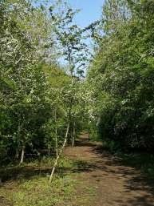
Middleton’s former railway line has been mentioned in the Middleton Messenger a couple of times and I thought it was time we let you all know what we have been doing. Firstly thank you to those who we have met whilst working on the railway line for all your positive comments; these are very encouraging. We have said hello to many people from the village we haven’t met before and Ruby has wagged her tail to greet you and your dog.
Well what have we been doing? – in February ERYC contractors began cutting down the hawthorn trees from the playing field end of the embankment; this was in order to create access to the large trees further along the
railway line towards the houses. They had removed over 18 trees, some over 50 years old, before they were stopped & alternative means of access considered. Damage done, it was apparent that natural recovery would take many years, so we decided on giving nature a helping hand. In March, after the contractors had gone, we planted birch trees donated by the Parish Council & added young hawthorn & rowan trees. Looking at the embankment in its entirety it was apparent that dog rose and brambles were dominant & running wild. Their vigorous growth over the years had smothered and excluded their competition –the hawthorns, ash, cherry and apple. The dog rose & brambles were also preventing light reaching the ‘woodland’ floor, so that wildflowers were a rarity, being unable to germinate and flourish. Next time you have a walk up there see if you can spot the two oak trees..
Well it just snowballed and the more we removed these unruly climbers the more we uncovered. It is our intention to only control the dog rose & brambles on the surface of the railway line, leaving them to continue to run amok on the flanks. We have unearthed many thin & weak saplings that were struggling to survive as a result of being suppressed by the invasive and aggressive competition!
Hawthorn, dog rose & brambles were the dominant species because only they could flourish in the embankment’s ‘soil’. This thin soil is primarily slag from the steel industry and therefore has very little nourishment in it. The embankment is also excessively well drained – the ‘bedrock’ is chalk & furnace ash. This said, it is amazing to see that, where areas have been cleared already there are wildflowers beginning to appear. Here comes the request: If you have spent compost from growing your tomato plants then please donate to us so that we can add it to the soil in readiness for planting further trees in the forthcoming autumn and winter. The compost will no longer be nutrient rich, but it will add important organic material. Our back garden is like a tree nursery in readiness for this - if you would like to help or have some old compost that you can’t use in your own garden going free please give Andrew a call on 219072 – leave a message and he will have a chat about what help he needs and he will also come round to pick up the compost in his wheelbarrow. Any young person willing & able to dig a planting hole would be especially welcome!
The young trees we planted in March (rowan, hawthorn and birch) were planted late & went through a very dry spring, so daily you can see us with our two watering cans giving them a much needed helping hand to establish/survive!. In fact one of the rowan trees is doing so well it has produced a single bunch of orange berries which have been eagerly taken by the birds.
All the trees that we intend to plant after the summer (including oaks!) will be native, and chosen for their blossom, berries & fruit. Extending the variety of trees should benefit insects, pollinators, birds & bats.
We have added small beds of foxgloves & primroses. It saddens me that despite putting up a sign to say please do not pick the foxgloves it appears that there has been further intentional damage. And recently we find too many used tissues and wipes strewn on the path - either they have fallen out of someone’s pocket or are deliberately dropped – this personal rubbish needs to be taken away or put in the bins – please do not leave it for other people like us to clear up after you - this is a potential health risk, particularly during these surreal and scary times. Dog mess likewise needs to be bagged & the bag placed in a bin.
In further reports I will let you know what wildflowers and trees you can see on the railway line. In the meantime don’t forget to leave the foxgloves alone so that they set seed so that we have plenty more to enjoy next year.
I hope you will continue to enjoy this part of the village – it is our very own woodland walk right on our doorstep – we are fortunate indeed, no need to drive off to enjoy this special place. Watch it become a wonderful woodland.
Liz Naylor
The wolds METHODIST CHURCH bainton
The chapel is still closed until further notice.
Hopefully there will be more positive news for you soon.

A note from your vicar

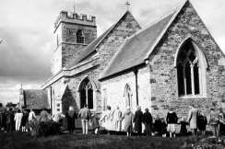
‘Clipping’ the Church
In Painswick, Gloucestershire on the Feast of the Nativity of the Blessed Virgin Mary, according to the old calendar – 19th September, the congregation, led by the choir process to the Parish Church for their Clipping Ceremony. ‘Clipping’ is an old word which means ‘to surround closely’. It is a lovely custom, in which the people make a circle around the church, join hands and ‘hug’ the building, giving thanks for the church as the heart of their community. I introduced this in my last parish, however, the congregation was no where near large enough to surround the building, so we held hands and made an outward facing circle inside the church!
The origins of church clipping are not really known, though this embracing of the church by the people goes back a long way. Reverend Seddon, who was vicar of Painswick in the late 1800’s wrote,
“When I came to Painswick some thirty years ago the Feast was kept as a popular, and especially as a children’s, festival. But the ‘clipping’ of the church had been intermittent for some years. Many old people of the village, however, well remember taking part in it in the days of their youth, and both name and custom were revived from their lips.”
Some think this tradition has its origins in the Roman Feast of Lupercalia, which included a sacred dance around the altar of Lupercalia and the sacrifice of young dogs. A link is made here between this and the ‘puppy-dog pies’ eaten at Painswick in Gloucestershire on Clipping Sunday. You will be relieved to know that these pies were plum pies with a little china dog in each. In more recent years the pies were replaced by buns – though I think hot dogs may have made a good substitute!
Church Clipping was or still is observed in Painswick, Burbage near Buxton, Wirksworth in Derbyshire, Radley in Oxfordshire and Guiseley in West Yorkshire. On each churches Patronal Festival.
As we are slowly returning to our churches across the Benefice it might be a good idea, when we can safely dispense with Social Distancing, to have our own ‘Clipping’ and give a thankful hug to the churches many of us deeply care for and have missed these past months.
I could not find a traditional ‘puppy dog pie’ recipe, however, this recipe may do if you have a glut of plums – it is called ‘Pickering Double Crust Pie’ taken from ‘Favourite Yorkshire Recipes’ compiled by Amanda Persey.
Pickering Double Crust Pie
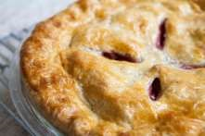
Pastry:
12 oz plain Flour
3 oz Butter
3 oz Lard ( or TREX)
1 Tablespoon Caster Sugar
1 Egg Yolk
Cold Water to Mix

Fruit Filling:
1 ½ Lbs Soft Fruit 4 oz Sugar, to taste.

Place fruit and sugar in a pan. Bring to the boil. Simmer gently until just soft. Leave to cool.
Put flour in large bowl and add butter, lard (or TREX) and cut into small pieces.
Rub fat into flour until it looks like breadcrumbs.
Stir in the sugar. Mix in egg yolk.
Add enough water to make a binding dough.
Put it in the fridge for 20 minutes.
Set oven to 400F, Gas 6, 200 C.
Roll out half of the pastry and line a deep 8 inch pie dish.
Strain fruit – reserving the juice.
Put fruit in the pastry lined dish.
Roll out remaining pastry to form a lid.
Dampen edges of pastry with water, add lid and press together – using a fork to edge the dish
Cut a couple of slits in top to allow steam to escape during cooking.
(you could use a pie funnel – I have a Cath Kidston ‘Stanley’ pie funnel in the shape of a little dog – very appropriate for ‘Puppy Dog Pie’)
Bake for 40-50 minutes. Cover with foil if it gets to over-brown – you need to make sure the base is cooked through – no soggy bottoms!
Serve warm or cold with the fruit juice.

I hope you enjoy it!

Jane
St Andrew’S church
Sunday 30th. August. No service
September Services
Sunday 6th No service
Sunday 13th Morning Prayers at 10.30.a.m Rev`d Jane Anderson.
Sunday 20th Morning Prayers at 10.30.a.m Rev`d Canon Kate Goulder Sunday 27th Morning Prayers at 10.30..a.m Rev`d Ruth Newton

Messenger correspondence
I think all of us are sick to death of being woken at 1 or sometimes 2 am by a car alarm! Twice the same one in a matter of days (second time being 2 am today (Sunday 2 August) and once a different one during the week.The owner of said vehicle obviously doesn’t get woken until around 10 minutes later each time it has gone off!!!
Can something be done about this or do I contact the Environmental Noise pollution people? I now cannot sleep as I’m expecting this terrible alarm noise to go off!
Angry resident Orchard Drive

While I sympathise with your problem there isn't anything the Messenger can do. If you can't resolve the issue with the car owner you should raise a complaint with East Riding of Yorkshire County Council.
Mike
Grapes:

Bacchus

Barbera

Carmen
è
re

Dornfelder

Grenache

Malbec

Mataro

Merlot

Muscat

Nebbiolo

Pinotage

Pinot Noir

Semillon

Shiraz

Viognier

Message:

Wine improves with age, the older I am
the more I like it.

Quiz answers

Word Search

1

Sacramento

2

William Roach

3

River Trent

4

Henry VIII

5

Kit
-
Kat

6

York City

7

Victor Hugo

8

Warsaw

9

Catherine Tate

10

Nineteen thirties (1931)

Middleton book group

Book review for Middleton Book Group – August 2020
We had a lovely afternoon in Pam’s garden in North Dalton, socially distancing in the shade of the trees. It was good to get together in person after a few months holding the meetings over Zoom.

This month we have been reading The Silence before Thunder by Kathy Shuker and The House share by Kate Helm.

The first one was enjoyed by everyone who read it , it tells the tale of a low key literary festival held in a small coastal village in the southwest. All the characters are known to each other and when one of them loses her memory after falling from her own terrace onto the rocks below, some one else has to take over the reins , and not everyone turns out to be whiter than white! Kathy Shuker created a web of intrigue that kept us all guessing right to the end.

The second book also dealt with a diverse group of people who all live as tenants in an old converted dye works, some of the people are lovely neighbours but others seem determined to do everything they can to make life difficult. There are times when scary things happen, and someone is playing mind games with those who are most vulnerable . I would recommend both of these books to anyone for holiday reading even though that may be in your own garden!!

Stay safe everyone and keep on reading

Pam

Next books for discussion:
“The Wind on the Moon” by Eric Linklater “Photographing Fairies” by Steve Szilagyi

To find out more about the Book Group please contact Lyn on 219500 or lyndennis456@gmail.com

Village hall news
Good News: The Village Hall is open again!
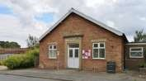
The flat roof has been completed, the store room cleaned and tidied and the hall equipped with the safety equipment, sanitisers and signage required to be COVID-19 compliant.
The Village Hall is now ready for use and has already been used for Pilates and for Yorkshire Countrywomen’s Association.
If you are using the Village Hall please comply with the signage showing the government instructions regarding social distancing, regular hand washing and hand gelling. Entry for people attending classes will be via the side fire doors and exit via the front doors to avoid a bottleneck in the entrance hall near the toilets. In the toilets, only one person at a time is to be in the ladies and one in the gents but the disabled toilet will also be in use.
If you would like to hire the hall for a private function please get in touch with me on lyndennis456@gmail.com
Our committee meetings will be on the first Tuesday in the month in future - 7.30pm in the VH. New members are very welcome. Lyn Dennis
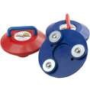will start again on
The Village Hall Committee

Thursday 3rd September at 2.00pm
We will place the chairs in a socially distanced circle for the seated exercise and follow this with a game of boccia
To start with we will not be using the kitchen so, if you would like a drink, please bring your own.
All care will be taken over sanitising equipment etc.
Please bring a mask in case it is needed.

Parish council
The Parish Council still has 2 vacancies for Councillors, and anyone who feels they would like to apply and that they could help bring new ideas and support the needs of the village should contact the Parish Clerk either in writing or email. Alternatively please feel free to approach any member of the Parish Council for further information.
Our meetings are still being carried out remotely using Zoom. We had our first 2 residents join us as guests at our last planning meeting, and they were able to listen and were also invited to contribute to the meeting. Anyone wishing to join our meeting should contact our Parish Clerk Sandra Morrison by email or phone (pc@middletononthewolds.co.uk or Telephone 01262 470496).
We have had various correspondences from residents concerning the traffic problems on the main road through Middleton. The sheer volume, size of vehicles, and the speed of travel, together with the general condition of the A614, is of great concern with several resident on Front Street concerned about both damage to their properties and to their wellbeing. We have had some encouraging correspondence from both our Ward Councillor and the ERYC Highways department, and we hope a site visit can be arranged to discuss what measures could be taken to improve the issues or what action we could take as a village community. The possibility of setting up a committee to push for major road improvements is something we should consider and would welcome support from anyone interested in joining such a committee / action group.
We are currently working towards opening up the Reading Rooms again. The building needs a full deep clean and provisions in line with the Covid19 guide rules need to be introduced. Please help support the Reading Rooms once they are reopened as the decoration works have vastly improved the ambiance of the building. The building needs to be used regularly in order to make it viable to run this public building as well as the Village Hall.
An additional litter bin has recently been installed (free of charge by the East Riding of Yorkshire Council) adjacent to the entrance of the public footpath, just outside the village on Beverley Road. This will be of great benefit to walkers as the route through the woods is being very well used at the moment. Please use the bin responsibly for general litter and dog waste when out walking.
John Eastwood

LITTER UPDATE
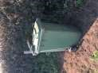
Good news!

Our new Green Bin has been installed on the bend on Beverley Road. It has a fixed opening latch and is suitable for small litter such as bottles, cans, food containers and most importantly bagged dog waste. When passing or out walking please use this facility and help keep our village clean and free of litter.This facility adds to the 10 litter bins that are situated around the village, do you know where they are?....
ERYC will empty the bin as part of their normal community service to our village.
Cheers

Nick Jones
Parish Councillor

Reading room news
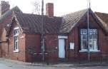
We are preparing the Reading Rooms so that they are COVID compliant with a view to opening for business in the near future. To this end it would help us to know what you, the villagers, want to see the Reading Rooms used for.
We will also be buying new furniture and it would
help us to know what kind you would like to see there. Do you want large or small tables? What kind of chairs? Would you like to see a sofa and a couple of armchairs? It would be great to hear from anyone who uses the Reading Rooms so that we can spend our money wisely.
Finally, we need committee members, particularly a secretary. If anyone would like to help run this important village amenity you would be more than welcome to join us.
For any of these topics please email me on mk@motwparishcouncil.co.uk.
Cheers,
Mike Kelly

Middleton on the wolds ce ve school
Executive Headteacher: Mrs E Harros
Station Road, Middleton on the Wolds, Driffield YO25 9UQ
E-mail:middleton.primary@eastriding.gov.uk Tel: 01377 217323

Clothing Collection Change of Date
Our next ‘Bag2school’ clothing collection has changed to Tuesday 29th September. Any unwanted clothes, shoes, handbags, hats, scarves, jewellery, belts or cuddly toys can go in the collection. The heavier the
collection, the more money that is raised for school, so please save all unwanted items for us. Bags must be in the school car park by 9am on Tuesday 29th September.

Middleton Minis
Following Government guidance, Middleton Minis will not be running for at least the first half term. Please look out in future newsletters for a re-opening date.

On-going Collections
On-going Collections – We collect used stamps and used batteries. Please note we are not currently collecting used printer cartridges or mobile phones until we can source a new company to collect and recycle them. Thank you.

Middleton on the Wolds Nursery
At Middleton on the Wolds CE (VC) Primary School

Providing education for 2, 3 and 4 year olds Monday - Friday.
We accept the Government’s childcare vouchers for up to 30 hours of free provision for 3 year olds (conditions apply)
Additional sessions can be purchased for £13.50 per session for 3 year olds and £15.75 for 2 year olds.
Lunchtime sessions are £1.75 (free if children attend for the whole day) with the option to purchase a school meal for £2.40.
Children are welcome in the term after their 3rd birthday for funded places.
For further details, please contact: Sharon Stone
Email: middleton.primary@eastriding.gov.uk Tel: 01377 217323

School Dates
School reopens at 08:40 am on Tuesday 8th September

Messenger correspondence
A Barrel of Sherry
My Dad was in the second world war – like most people who were in it, he rarely talked about it except for this one particular episode:-
My Dad was in the Kings Own Royal Regiment – 1st battalion.
They had fought in North Africa and had been shipped to Cyprus in January 1943 as a staging post before going along with other regiments as a force of 3000+ men to the ill fated Dodecanese Islands campaign.
They landed in the port of Famagusta in Cyprus and were given supplies for a ‘few’ weeks and told to split up and set up camps on the beaches etc while the necessary forces assembled. So, a number of pals including my Dad, grouped together (actual figure unknown – possibly about 30/40), and they walked down the beach for nearly a mile and set up camp. They had noticed that on the quay side there were about 30 huge barrels of vintage Cyprus sherry ready to be shipped out so the Germans couldn’t have them. A collective thought was that one barrel would not be missed. That night, they camouflaged up and set off back down the beach. They managed to tip one barrel over and then role it on to the sand. As it progressed slowly back to the camp, in order to hide their trail, a detachment of men with shovels filled in the groove it cut in to the sand. When they arrived back at the camp they dug a hole big enough to drop the barrel in. The barrel went in the hole the right way up and its top was about 2 or 3 feet below the surface of the beach. They covered the barrel with sand except for a small area in the middle where they used their ground sheets to stop the sand drifting on to it. They had a carpenter in their midst who carefully cut a hole in to the oak barrel and fashioned a bucket on a rope to access the vintage sherry below. They then all sat round the opening, eating bully beef and chatting away as they ‘sipped’ the sherry for the next week or so. Apparently, as they became worse for wear and fell asleep, others who were at that time waking up, would cover them up and then they did ‘their bit’ to see how much of the sherry could be prevented from falling into enemy hands. You must agree it was a noble quest.
All too soon they had orders to assemble back at the dock. The level of the sherry in the barrel had only dropped a little, so the carpenter repaired the hole and made it air tight and covered it up with sand. The plan was if they came back to the island, they could continue with their ‘sherry based’ endeavours. However, the campaign was ill fated and all but 51 men of the regiment where either killed or captured and the lucky ones spent the rest of the war in German prison of war camps.
The thought is that the barrel was well hidden, made of oak, water and air tight and will be by now 80 plus years old - and worth a fortune. It was already vintage when it was snatched from the oncoming grasp of the Germans and it’s probably still there. Good hunting. Geoff Cox

Dog Poo in the Village

9 out of 10 dog owners pick up their dog’s poo – don’t you be the one that doesn’t.
Middleton has a wonderful community spirit and one which I am proud to be part of. We look out for our friends and families and help one another where we can. However there is one “habit” that needs to become history. Why do people feel that it is okay to leave their dog’s poo on the path; either in the street, in the woods or on public bridleways? What’s just as bad is leaving your dog poo bag hung on a tree or left at the side of the path. Here in Middleton you are never far from a waste bin – in fact there are 10 around the village for you to use. Please view the map for details.
We all need to be respectful and considerate to everyone who lives in the village so I implore you to always pick up your dog’s poo – don’t leave it for someone to tread in and spread it, don’t leave your poo bag for someone else to pick up and dispose of. I have seen a poo bag not 10 yards from a public bin – why? Educate members of your family who take your dog for a walk – always ensure they have a poo bag on them. Did you know:
- A dog's digestive system can handle just about anything and often does; making it's poo very toxic. In fact, a single dog will produce more bacteria in one day than a person, a horse and a cow combined.
- On average, a dog poo’s twice per day which adds up to about 14 piles of poo in just one week, and that is just one dog. It has the same amount of bacteria as 14 wheelbarrow loads of combined human poo, cow poo and horse poo.
- Dog waste is an environmental pollutant. Just 30g of dog poo can contain over 23 million microorganisms of bacteria. That’s twice as much as human faeces! Picking up your dog’s waste isn’t just a common courtesy, it’s a health imperative. Picking up after your dog helps reduce the likelihood of its faecal bacteria ending up in an increasingly contaminated water supply.
- Disease and viruses such as E.Coli and Coccidia can be spread in dog faeces. Again, possibly passing it on to humans, especially children playing in poo prevalent areas such as parks and woods.
- That dog poo can contain worms and their eggs. Some of them, like toxocara canis (roundworm), can cause disease or infections in humans. Just one pile of dog poo can contain a million roundworm eggs! In humans this can lead to stomach upsets, throat infections, asthma and in some cases blindness. Over 100 cases of partial blindness in children are seen every year due to toxocara canis eggs in faeces. Cleaning up after dogs and having a regular de-worming programme can help bring this number down.
- What’s even scarier is that only an estimated 60% of dog owners even bother to de-worm their pets! So eggs are more prevalent than ever in our environment.
- Dog poo washes into water supplies and kills wildlife.
- Dog poo is a protein by-product and will attract rats that will eat the undigested protein found in the faecal matter.
- Contrary to popular belief a dog faeces is not a fertilizer and does not provide any benefit to the soil.
How many times have you heard someone tell you not to worry about a particular piece of poo because it was about to rain soon. Not picking up fresh poo before rainfall is even worse than letting it sit on a dry day! When the rain washes over dog poo and flows into the drainage system, it contaminates our ground water – the principle source of our drinking water.
Dog Poo and the Law
It is in fact LAW that dog owners pick up after their pets and yet so many show little respect for the environment and others by not abiding to it. If your dog fouls in a public place, you must clean up the mess under the Dog Act 1996. The amount of the fine varies between different local authorities, but is often £50 and may be as much as £80. If a person refuses to pay the fine, they can be prosecuted and may face a court appearance with a maximum penalty of £1,000. Registered blind dog owners are exempt from penalties.
What do we do with dog poo?
The next time you take your dog to the park or on a walk, please take the time to clean up. Even if your dog only poos in your backyard or garden, letting it remain unattended is an invitation for illness and endangers others in your community. If you haven’t got a poo bag it is respectful to move your dog’s poo away from the path; ensure that it is well away from where people or other dogs can step in it; especially as during this difficult time we have to move aside sometimes into the undergrowth to allow other walkers to get by to ensure the social distancing rules are applied.
It isn't fun or glamorous, but picking up dog poo is a necessary part of dog ownership. Picking up your dog’s poo is an easy way to prevent disease, keeping your community's environment healthy, village’s dog owners and non-dog owners smiling.
Be a responsible pet owner – clean up after your dog!

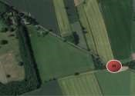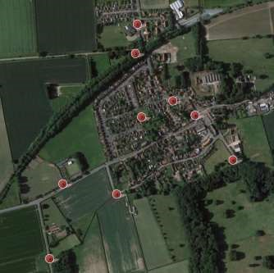
Key to the Map:
Where the waste bins located in Middleton on the Wolds: 1: Outside the School
2: Warter Road, bottom of the steps leading to the railway line
3: At the entrance to the Playing Fields
4: At the top of Mill Trod, on Goodmanham Road
5: At the bottom of Mill Trod, on the corner of South Street
6: By the parking space by the Cemetery
7: By the young children’s play area, Orchard Drive
8: By the village pond
9: By the village hall on Station Road
10: Large green bin by the footpath entrance/parking space on Beverley Road
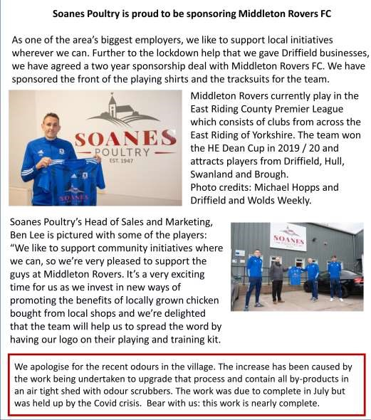
Advertising Feature

Advertisement
Advertising Feature

Regular group activities
Weekly Groups
Monday Pilates 6.00-7.00pm Village Hall Thursday Middleton Movers 2.00-3.30pm Village Hall

September
1 Village Hall Committee 7.30pm Village Hall
- Parish Council 7.00pm Zoom
- Book Group 2.00pm Ring 219500 for venue
13 Middleton Womblers 10.00am Lime View
15 Country Women’s 7.30pm Village Hall

LOCAL CONTACTS Bell Ringing Chris Atkin |  | 217285
Book Group/Middleton Movers | Lyn Dennis | 219500
Bowls Club | Rob Bradley | 217435
Country Women’s Association | Christine Johnson | 217374
First Responders | Chris Brent | 219469
Line Dancing | Pat Pottage | 217516
Methodist Chapel | Miss P Hodgson | 217426
Middleton Messenger | Mike Kelly | 07713 620912
 | Lyn Dennis | 219500
 | Tina Walker | 217242
Middleton Womblers | Andrew Naylor | 219072
Parish Clerk | Sandra Morrison | 01262 470496
Pilates | Ian Stephenson | 07973 755717
Reading Rooms | Kath Bentley | 217456
Recreation Club | Dave Newlove | 07901 833784
St Andrew’s Church | Rev Jane Anderson | 219471
St Andrew’s Church Warden | Roger Lowe | 217656
Table Tennis | Louise Newlove | 217801
Village Hall | Lyn Dennis | 219500
Village History | Geoff Wisher | 217517

